23 Perfect Competition


Learning Objectives
After reading this chapter, you should be able to:
- 23.1 Identify the characteristics of a perfectly competitive market structure
- 23.2 Discuss the process by which a perfectly competitive firm decides how much output to produce
- 23.3 Understand how the short-run supply curve for a perfectly competitive firm is determined
- 23.4 Explain how the equilibrium price is deter-mined in a perfectly competitive market
- 23.5 Describe what factors induce firms to enter or exit a perfectly competitive industry and distinguish among constant-, increasing-, and decreasing-cost industries based on the shape of the long-run industry supply curve
MyEconLab helps you master each objective and study more efficiently. See the end of the chapter for details.
As in past years, this year more than 500,000 entrepreneurs will open new businesses in the United States. They will do so with the expectations that their firms will earn economic profits, and many initially will do so. Nevertheless, within a few years’ time, most entrants to U.S. markets will find themselves struggling to survive. Most firms that earn economic profits at the outset will soon experience dwindling average annual profits. Many other firms will find themselves engaged in a persistent battle simply to try to earn accounting profits sufficient to cover owners’ opportunity costs. Indeed, half of all new firms will choose to bring their operations to a permanent halt within about five years. Ultimately, fewer than one of four new firms will still be in business twenty years from now. In this chapter, you will learn about how competition results in such a tenuous likelihood of survival for firms that enter U.S. markets for goods and services.

Did You Know That…
some of the land around Houston, Texas, which years ago had been deemed unsuitable for further oil production and transformed into areas of residential housing, is now part of wide area of renewed oil production? An initial reason that drilling for additional oil was renewed had been that the price of oil had jumped a few years ago. As a consequence, the contribution to an oil firm’s revenues from drilling for another unit of oil increased. Another reason is that oil companies have developed new oil-drilling techniques. In past years, the firms sank drills into the ground vertically in order to tap underground pools of oil. Now they have discovered a horizontal drilling technique called fracking that enables them to recover oil from rock shale formations at lower cost than in the past—and to drill for oil beneath today’s residential homes.
Hence, shortly after the additional revenue from a unit of oil had increased, the additional cost of obtaining that unit of oil declined, which induced firms to drill anew for more oil under some Houston lands. As you will learn in this chapter, for any firm both the additional revenue and the additional cost generated by an increase in production are crucial to determining how much of any item, including oil, they will produce.

Characteristics of a Perfectly Competitive Market Structure
- 23.1 Identify the characteristics of a perfectly competitive market structure
We are interested in studying how a firm acting within a perfectly competitive market structure makes decisions about how much to produce. In a situation of perfect competition, each firm is such a small part of the total industry that it cannot affect the price of the product in question. That means that each perfectly competitive firm in the industry is a price taker—the firm takes price as a given, something determined outside the individual firm.
Perfect competition
A market structure in which the decisions of individual buyers and sellers have no effect on market price.
Perfectly competitive firm
A firm that is such a small part of the total industry that it cannot affect the price of the product it sells.
Price taker
A perfectly competitive firm that must take the price of its product as given because the firm cannot influence its price.

What It Means for a Firm to Be a Price Taker
The definition of a competitive firm is obviously idealized, for in one sense the individual firm has to set prices. How can we ever have a situation in which firms regard prices as set by forces outside their control? The answer is that even though every firm sets its own prices, a firm in a perfectly competitive situation will find that it will eventually have no customers at all if it sets its price above the competitive price.
The best example is in agriculture. Although the individual farmer can set any price for a bushel of wheat, if that price doesn’t coincide with the market price of a bushel of similar-quality wheat, no one will purchase the wheat at a higher price. Nor would the farmer be inclined to reduce revenues by selling below the market price.
MyEconLab Concept Check

Characteristics of Perfect Competition
Let’s examine why a firm in a perfectly competitive industry is a price taker.
- There are large numbers of buyers and sellers. When this is the case, the quantity demanded by one buyer or the quantity supplied by one seller is negligible relative to the market quantity. No one buyer or seller has any influence on price.
- The product sold by the firms in the industry is homogeneous—that is, indistinguishable across firms.The product sold by each firm in the industry is a perfect substitute for the product sold by every other firm. Buyers are able to choose from a large number of sellers of a product that the buyers regard as being the same.
- Both buyers and sellers have access to all relevant information. Consumers are able to find out about lower prices charged by competing firms. Firms are able to find out about cost-saving innovations that can lower production costs and prices, and they are able to learn about profitable opportunities in other industries.
- Any firm can enter or leave the industry without serious impediments. Firms in a competitive industry are not hampered in their ability to get resources or redistribute resources. In pursuit of profit-making opportunities, they reallocate labor and capital to whatever business venture gives them their highest expected rate of return on their investment.
In what ways does the market for no-frills legal services exhibit characteristics of a perfectly competitive industry?

Example Features of Perfect Competition in the Market for Basic Legal Services
Employees at many legal firms perform the same basic tasks every day. Some employees enter names into online forms for wills and execute the wills at secure Internet sites. Others perform similar tasks using Web forms for divorces. Still others complete and submit online forms legally finalizing property transfers.
Of course, thousands of no-frills law firms complete a considerable amount of routine law work on paper documents that are filed physically with courts, county clerks, and other government and private legal offices. These firms compete both online and offline to handle mundane legal matters, including standard wills, uncontested divorces, and basic property transfers. Hence, these products are homogeneous. There are virtually no uncertainties associated with these transactions, which are highly standardized in most legal jurisdictions. Consequently, parties have access to all relevant information. Finally, numerous people can obtain the essential training required to perform basic legal services, so it is relatively easy to enter or exit the market for these services. This industry, therefore, exhibits the key characteristics of perfect competition.

For Critical Thinking
- Why are law firms that specialize in providing legal services in complex criminal and civil cases involving jury trials less likely to be perfectly competitive firms?
Sources are listed at the end of this chapter.
MyEconLab Concept Check
MyEconLab Study Plan

Self Check
Visit MyEconLab to practice these and other problems and to get instant feedback in your Study Plan.
- In perfectly competitive markets, there are numbers of well-informed and sellers.
- Perfectly competitive firms sell products and can exit or enter the industry.

Profit-Maximizing Choices of a Perfectly Competitive Firm
- 23.2 Discuss the process by which a perfectly competitive firm decides how much output to produce
When we discussed substitutes in Chapter 19, we pointed out that the more substitutes there are and the more similar they are to the commodity in question, the greater is the price elasticity of demand. Here we assume that the perfectly competitive firm is producing a homogeneous (indistinguishable across all of the industry’s firms) commodity that has perfect substitutes. That means that if the individual firm raises its price one penny, it will lose all of its business. This, then, is how we characterize the demand schedule for a perfectly competitive firm: It is the going market price as determined by the forces of market supply and market demand—that is, where the market demand curve intersects the market supply curve. The demand curve for the product of an individual firm in a perfectly competitive industry is perfectly elastic at the going market price. Remember that with a perfectly elastic demand curve, any increase in price leads to zero quantity demanded.
We show the market demand and supply curves in panel (a) of Figure 23-1 on the next page. Their intersection occurs at the price of $5. The commodity in question is flash memory cards. Assume for the purposes of this exposition that all of these flash memory cards are perfect substitutes for all others. At the going market price of $5 apiece, the demand curve for flash memory cards produced by an individual firm that sells a very, very small part of total industry production is shown in panel (b). At the market price, this firm can sell all the output it wants. At the market price of $5 each, which is where the demand curve for the individual producer lies, consumer demand for the flash memory cards of that one producer is perfectly elastic.
MyEconLab Animation
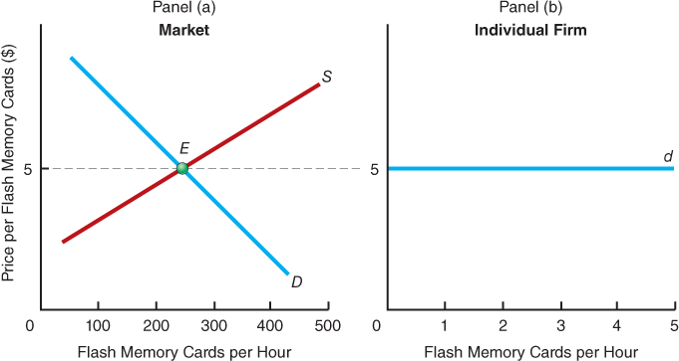

Figure 23-1 The Demand Curve for a Producer of Flash Memory Cards
At $5—where market demand, D, and market supply, S, intersect—the individual firm faces a perfectly elastic demand curve, d. If the firm raises its price even one penny, it will sell no flash memory cards, measured from its point of view in hourly production, at all. (Notice the difference in the quantities of flash memory cards represented on the horizontal axes of panels (a) and (b).)
This can be seen by noting that if the firm raises its price, consumers, who are assumed to know that this supplier is charging more than other producers, will buy elsewhere, and the producer in question will have no sales at all. Thus, the demand curve for that producer is perfectly elastic. We label the individual producer’s demand curve d, whereas the market demand curve is always labeled D.

How Much Should the Perfect Competitor Produce?
As we have shown, from the perspective of a perfectly competitive firm deciding how much to produce, the firm has to accept the price of the product as a given. If the firm raises its price, it sells nothing. If it lowers its price, it earns lower revenues per unit sold than it otherwise could. The firm has one decision left: How much should it produce? We will apply our model of the firm to this question to come up with an answer. We’ll use the profit-maximization model,which assumes that firms attempt to maximize their total profits—the positive difference between total revenues and total costs. This also means that firms seek to minimize any losses that arise in times when total revenues may be less than total costs.

Total Revenues
Every firm has to consider its total revenues. Total revenues are defined as the quantity sold multiplied by the price per unit. (They are the same as total receipts from the sale of output.) The perfect competitor must take the price as a given.
Total revenues
The price per unit times the total quantity sold.
Look at Figure 23-2 on the next page. The information in panel (a) comes from panel (a) of Figure 22-2 on page 510, but we have added some essential columns for our analysis. Column 3 is the market price, P, of $5 per flash memory card. Column 4 shows the total revenues, or TR, as equal to the market price, P, times the total output per hour, or Q. Thus, TR = PQ.
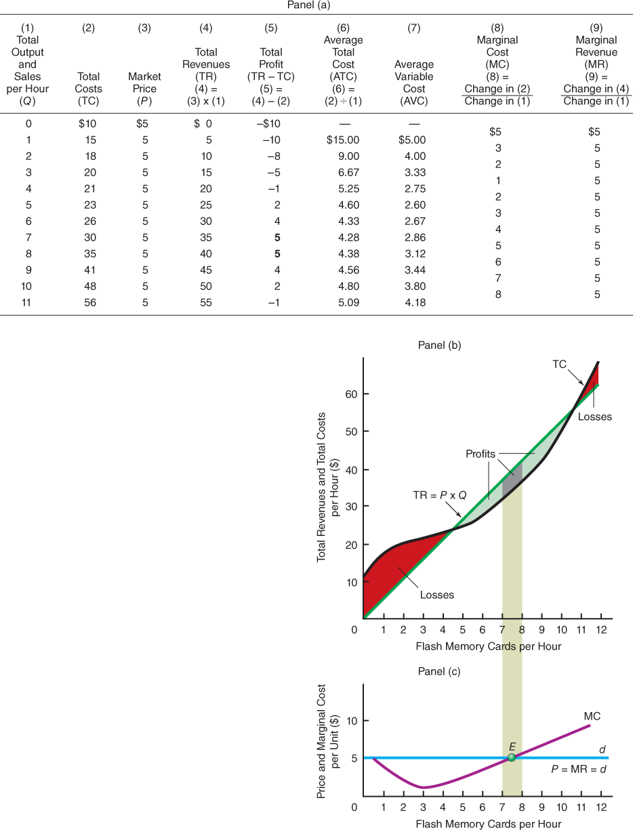

Figure 23-2 Profit Maximization
Profit maximization occurs where marginal revenue equals marginal cost. Panel (a) indicates that this point occurs at a rate of sales of between seven and eight flash memory cards per hour. In panel (b), we find maximum profits where total revenues exceed total costs by the largest amount. This occurs at a rate of production and sales per hour of seven or eight flash memory cards. In panel (c), the marginal cost curve, MC, intersects the marginal revenue curve at the same rate of output and sales of somewhere between seven and eight flash memory cards per hour.
We are assuming that the market supply and demand schedules intersect at a price of $5 and that this price holds for all the firm’s production. We are also assuming that because our maker of flash memory cards is a small part of the market, it can sell all

Short-Run Supply Under Perfect Competition
- 23.3 Understand how the short-run supply curve for a perfectly competitive firm is determined
In Chapter 3, you learned that in a market with many buyers and sellers, the equilibrium price and quantity arise when the total quantity of the product demanded equals the total quantity supplied. In a perfectly competitive market, the quantity supplied is determined along an industry supply curve, which in turn depends on the supply curves of all the firms in the market. To understand how to obtain supply curves for perfectly competitive firms and for the industry as a whole, you first must understand the determination of firms’ economic profits.

Short-Run Profits
To find what our competitive individual producer of flash memory cards is making in terms of profits in the short run, we have to add the average total cost curve to panel (c) of Figure 23-2 on page 532. We take the information from column 6 in panel (a) and add it to panel (c) to get Figure 23-3 below. Again the profit-maximizing rate of output is between seven and eight flash memory cards per hour. If we have production and sales of seven per hour, total revenues will be $35 per hour. Total costs will be $30 per hour, leaving a profit of $5 per hour. If the rate of output and sales is eight flash memory cards per hour, total revenues will be $40 and total costs will be $35, again leaving a profit of $5 per hour.

A Graphical Depiction of Maximum Profits
In Figure 23-3 below, the lower boundary of the rectangle labeled “Profits” is determined by the intersection of the profit- maximizing quantity line represented by vertical dashes and the average total cost curve. Why? Because the ATC curve gives us the cost per unit, whereas the price ($5), represented by d, gives us the revenue per unit, or average revenue. The difference is profit per unit.
MyEconLab Animation
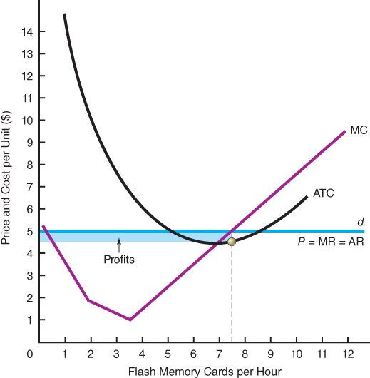

Figure 23-3 Measuring Total Profits
Profits are represented by the blue-shaded area. The height of the profit rectangle is given by the difference between average total costs and price ($5), where price is also equal to average revenue. This is found by the vertical difference between the ATC curve and the price, or average revenue, line d, at the profit-maximizing rate of output of between seven and eight flash memory cards per hour.
MyEconLab Animation
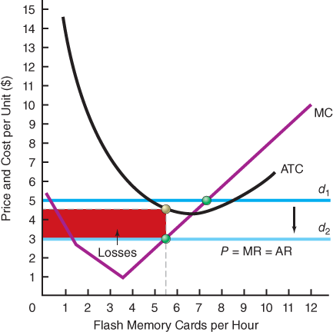

Figure 23-4 Minimization of Short-Run Losses
In situations in which average total costs exceed price, which in turn is greater than or equal to average variable cost, profit maximization is equivalent to loss minimization. Losses are minimized at the output rate at which marginal cost equals marginal revenue. Losses are shown in the red-shaded area.
Thus, the height of the rectangular box representing profits equals profit per unit, and the length equals the amount of units produced. When we multiply these two quantities, we get total profits. Note, as pointed out earlier, that we are talking about economic profits because a normal rate of return on investment plus all opportunity costs is included in the average total cost curve, ATC.

A Graphical Depiction of Minimum Losses
It is also certainly possible for the competitive firm to make short-run losses. We give an example in Figure 23-4above, where we show the firm’s demand curve shifting from d₁ to d₂. The going market price has fallen from $5 to $3 per flash memory card because of changes in market demand conditions. The firm will still do the best it can by producing where marginal revenue equals marginal cost.
We see in Figure 23-4 that the marginal revenue (d₂) curve is intersected (from below) by the marginal cost curve at an output rate of about 512512 flash memory cards per hour. The firm is clearly not making profits because average total costs at that output rate are greater than the price of $3 per flash memory card. The losses are shown in the shaded area. By producing where marginal revenue equals marginal cost, however, the firm is minimizing its losses. That is, losses would be greater at any other output.
MyEconLab Concept Check

The Short-Run Break-Even Price and the Short-Run Shutdown Price
In Figure 23-4 above, the firm is sustaining economic losses. Will it go out of business? In the long run it will, but in the short run the firm will not necessarily go out of business. In the short run, as long as the total revenues from continuing to produce output exceed the associated total variable costs, the firm will remain in business and continue to produce. A firm goes out of business when the owners sell its assets to someone else. A firm temporarily shuts down when it stops producing, but it still is in business.
Now how can a firm that is sustaining economic losses in the short run tell whether it is still worthwhile not to shut down? The firm must compare the total revenues that it receives if it continues producing with the resulting total variable costs that it thereby incurs. Looking at the problem on a per-unit basis, as long as average variable cost (AVC) is covered by average revenues (price), the firm is better off continuing to produce. If average variable costs are exceeded even a little bit by the price of the product, staying in production produces some revenues in excess of variable costs. The logic is fairly straightforward:
MyEconLab Animation
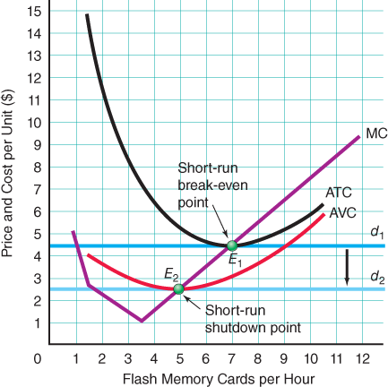

Figure 23-5 Short-Run Break-Even and Shutdown Prices
We can find the short-run break-even price and the short-run shutdown price by comparing price with average total costs and average variable costs. If the demand curve is d₁, profit maximization occurs at output E₁, where MC equals marginal revenue (the d₁ curve). Because the ATC curve includes all relevant opportunity costs, point E₁ is the break-even point, and zero economic profits are being made. The firm is earning a normal rate of return. If the demand curve falls to d₂, profit maximization (loss minimization) occurs at the intersection of MC and MR (the d₂ curve), or E₂. Below this price, it does not pay for the firm to continue in operation because its average variable costs are not covered by the price of the product.
As long as the price per unit sold exceeds the average variable cost per unit produced, the earnings of the firm’s owners will be higher if it continues to produce in the short run than if it shuts down.

Calculating the Short-Run Break-Even Price
Look at demand curve d₁ in Figure 23-5 above. It just touches the minimum point of the average total cost curve, which is exactly where the marginal cost curve intersects the average total cost curve. At that price, which is about $4.30, the firm will be making exactly zero short-run economic profits. That price is called the short-run break-even price, and point E₁ therefore occurs at the short-run break-even price for a competitive firm. It is the point at which marginal revenue, marginal cost, and average total cost are all equal (that is, at which P = MC and P = ATC ). The break-even price is the one that yields zero short-run economic profits or losses.
Short-run break-even price
The price at which a firm’s total revenues equal its total costs. At the break-even price, the firm is just making a normal rate of return on its capital investment. (It is covering its explicit and implicit costs.)

Calculating the Short-Run Shutdown Price
To calculate the firm’s shutdown price, we must introduce the average variable cost (AVC) to our graph. In Figure 23-5, we have plotted the AVC values from column 7 in panel (a) of Figure 23-2 on page 532. For the moment, consider two possible demand curves, d₁ and d₂, which are also the firm’s respective marginal revenue curves. If demand is d₁, the firm will produce at E₁, where that curve intersects the marginal cost curve. If demand falls to d₂, the firm will produce at E₂. The special feature of the hypothetical demand curve, d₂, is that it just touches the average variable cost curve at the latter’s minimum point, which is also where the marginal cost curve intersects it. This price is the short-run shutdown price. Why? Below this price, the firm would be paying out more in variable costs than it is receiving in revenues from the sale of its product. Each unit it sold would generate losses that could be avoided if it shut down operations.
Short-run shutdown price
The price that covers average variable costs. It occurs just below the intersection of the marginal cost curve and the average variable cost curve.
The intersection of the price line, the marginal cost curve, and the average variable cost curve is labeled E₂. The resulting short-run shutdown price is valid only for the short run because, of course, in the long run the firm will not stay in business if it is earning less than a normal rate of return (zero economic profits).

The Meaning of Zero Economic Profits
The fact that we labeled point E₁ in Figure 23-5 on the previous page the break-even point may have disturbed you. At point E₁, price is just equal to average total cost. If this is the case, why would a firm continue to produce if it were making no profits whatsoever?

Accounting Profits versus Economic Profits
If we again make the distinction between accounting profits and economic profits, you will realize that at that price, the firm has zero economic profits but positive accounting profits. Recall that accounting profits are total revenues minus total explicit costs. Such accounting, however, ignores the reward offered to investors—the opportunity cost of capital—plus all other implicit costs.
In economic analysis, the average total cost curve includes the full opportunity cost of capital. Indeed, the average total cost curve includes the opportunity cost of all factors of production used in the production process. At the short-run break-even price, economic profits are, by definition, zero. Accounting profits at that price are not, however, equal to zero. They are positive.

An Example of Zero Economic Profits
Consider an example. A manufacturer of homogeneous nanotube chips sells chips at some price. The owners of the firm have supplied all the funds in the business. They have not borrowed from anyone else, and they explicitly pay the full opportunity cost to all factors of production, including any managerial labor that they themselves contribute to the business. Their salaries show up as a cost in the books and are equal to what they could have earned in the next-best alternative occupation.
At the end of the year, the owners find that after they subtract all explicit costs from total revenues, accounting profits are $100,000. If their investment was $1 million, the rate of return on that investment is 10 percent per year. We will assume that this turns out to be equal to the market rate of return.
This $100,000, or 10 percent rate of return, is actually, then, a competitive, or normal, rate of return on invested capital in all industries with similar risks. If the owners had made only $50,000, or 5 percent on their investment, they would have been able to make higher profits by leaving the industry. The 10 percent rate of return is the opportunity cost of capital. Accountants show it as a profit. Economists call it a cost. We include that cost in the average total cost curve, similar to the one shown in Figure 23-5 on the previous page. At the short-run break-even price, average total cost, including this opportunity cost of capital, will just equal that price. The firm will be making zero economic profits but a 10 percent accounting profit.
MyEconLab Concept Check

The Perfect Competitor’s Short-Run Supply Curve
As you learned in Chapter 3, the relationship between a product’s price and the quantity produced and offered for sale is a supply curve. What does the supply curve for the individual firm look like? Actually, we have been looking at it all along. We know that when the price of flash memory cards is $5, the firm will supply seven or eight of them per hour. If the price falls to $3, the firm will supply five or six flash memory cards per hour. If the price falls below the minimum point along the average variable cost, the firm will shut down. Hence, in Figure 23-6 on the next page, the firm’s supply curve is the marginal cost curve above the short-run shutdown point. This is shown as the solid part of the marginal cost curve.
By definition, then, a firm’s short-run supply curve in a competitive industry is its marginal cost curve at and above the point of intersection with the average variable cost curve.
MyEconLab Concept Check

The Short-Run Industry Supply Curve
In Chapter 3, we indicated that the market supply curve was the summation of individual supply curves. At the beginning of this chapter, we drew a market supply curve in Figure 23-1 on page 531. Now we want to derive more precisely a market, or industry, supply curve to reflect individual producer behavior in that industry.
MyEconLab Animation
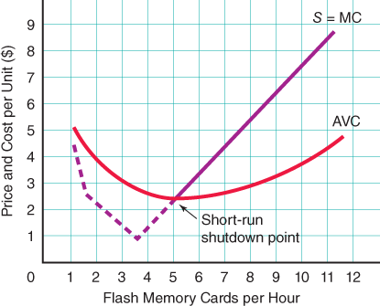

Figure 23-6 The Individual Firm’s Short-Run Supply Curve
The individual firm’s short-run supply curve is the portion of its marginal cost curve at and above the minimum point on the average variable cost curve.

Determining the Industry
First we must ask, What is an industry? It is merely a collection of firms producing a particular product.
Therefore, we have a way to figure out the total supply curve of any industry: As discussed in Chapter 3, we add the quantities that each firm will supply at every possible price. In other words, we sum the individual supply curves of all the competitive firms horizontally. The individual supply curves, as we just saw, are simply the marginal cost curves of each firm.

Constructing the Industry Supply Curve
Consider doing this for a hypothetical world in which there are only two producers of flash memory cards in the industry, firm A and firm B. These two firms’ marginal cost curves are given in panels (a) and (b) of Figure 23-7 on the next page. The marginal cost curves for the two separate firms are presented as MC_{A} in panel (a) and MC_{B} in panel (b). Those two marginal cost curves are drawn only for prices above the minimum average variable cost for each respective firm. In panel (a), for firm A, at a price of $6 per unit, the quantity supplied would be 7 units. At a price of $10 per unit, the quantity supplied would be 12 units. In panel (b), we see the two different quantities that would be supplied by firm B corresponding to those two prices. Now, at a price of $6, we add horizontally the quantities 7 and 10 to obtain 17 units. This gives us one point, F, for our short-run industry supply curve, S. We obtain the other point, G, by doing the same horizontal adding of quantities at a price of $10 per unit.
Industry supply curve
The locus of points showing the minimum prices at which given quantities will be forthcoming; also called the market supply curve.
When we connect all points such as F and G, we obtain the industry supply curve S, which is also marked ΣMC(where the capital Greek sigma, Σ, is the symbol for summation), indicating that it is the horizontal summation of the marginal cost curves (at and above the respective minimum average variable cost of each firm). Because the law of diminishing marginal product makes marginal cost curves rise as output rises, the short-run supply curve of a perfectly competitive industry must be upward sloping.
MyEconLab Concept Check

Factors That Influence the Industry Supply Curve
As you have just seen, the industry supply curve is the horizontal summation of all of the individual firms’ marginal cost curves at and above their respective minimum average variable cost points. This means that anything that affects the marginal cost curves of the firm will influence the industry supply curve. Therefore, the individual factors that will influence the supply schedule in a competitive industry can be summarized as the factors that cause the variable costs of production to change. These are factors that affect the individual marginal cost curves, such as changes in the individual firm’s productivity, in factor prices (such as wages paid to labor and prices of raw materials), in per-unit taxes, and in anything else that would influence the individual firm’s marginal cost curve.
MyEconLab Animation
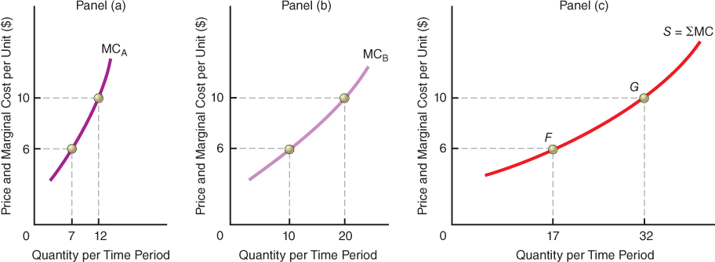

Figure 23-7 Deriving the Industry Supply Curve
Marginal cost curves at and above minimum average variable cost are presented in panels (a) and (b) for firms A and B. We horizontally sum the two quantities supplied, 7 units by firm A and 10 units by firm B, at a price of $6. This gives us point F in panel (c). We do the same thing for the quantities supplied at a price of $10. This gives us point G. When we connect those points, we have the industry supply curve, S, which is the horizontal summation—represented by the Greek letter sigma (Σ)—of the firms’ marginal cost curves above their respective minimum average variable costs.
All of these are ceteris paribus conditions of supply (see page 57 in Chapter 3). Because they affect the position of the marginal cost curve for the individual firm, they affect the position of the industry supply curve. A change in any of these will shift the firms’ marginal cost curves and thus shift the industry supply curve.
MyEconLab Concept Check
MyEconLab Study Plan

Self Check
Visit MyEconLab to practice these and other problems and to get instant feedback in your Study Plan.
- Short-run average profits or losses are determined by comparing total costs with at the profit-maximizing rate of output. In the short run, the perfectly competitive firm can make economic profits or economic losses.
- The perfectly competitive firm’s short-run - price equals the firm’s minimum average total cost, which is at the point at which the cost curve intersects the average total cost curve.
- The perfectly competitive firm’s short-run price equals the firm’s minimum average variable cost, which is at the point at which the cost curve intersects the average variable cost curve. Shutdown will occur if price falls below average variable cost.
- The firm will continue production at a price that exceeds average variable costs because revenues exceed total costs of producing.
- At the short-run break-even price, the firm is making economic profits, which means that it is just making a rate of return for industries with similar risks.
- The firm’s short-run supply curve is the portion of its cost curve at and above its minimum average cost.
- The industry short-run supply curve is a horizontal of the individual firms’ marginal cost curves at and above their respective minimum average costs.

Price Determination Under Perfect Competition
- 23.4 Explain how the equilibrium price is determined in a perfectly competitive market
How is the market, or “going,” price established in a competitive market? This price is established by the interaction of all the suppliers (firms) and all the demanders (consumers).

The Market Clearing Price
The market demand schedule, D, in panel (a) of Figure 23-8 below represents the demand schedule for the entire industry, and the supply schedule, S, represents the supply schedule for the entire industry. The market clearing price, P_{e}, is established by the forces of supply and demand at the intersection of D and the short-run industry supply curve, S. Even though each individual firm has no control or effect on the price of its product in a competitive industry, the interaction of all the producers and buyers determines the price at which the product will be sold.
We say that the price P_{e} and the quantity Q_{e} in panel (a) of Figure 23-8 constitute the competitive solution to the resource allocation problem in that particular industry. It is the equilibrium at which quantity demanded equals quantity supplied, and both suppliers and demanders are doing as well as they can. The resulting individual firm demand curve, d, is shown in panel (b) of Figure 23-8 at the price P_{e}.
MyEconLab Concept Check

Market Equilibrium and the Individual Firm
In a purely competitive industry, the individual producer takes price as a given and chooses the output level that maximizes profits. (This is also the equilibrium level of output from the producer’s standpoint.) We see in panel (b) of Figure 23-8 below that this is at q_{e}. If the producer’s average costs are given by AC₁, the short-run break-even price arises at q_{e} (see Figure 23-5 on page 537). If its average costs are given by AC₂, then at q_{e}, AC exceeds price (average revenue), and the firm is incurring losses. Alternatively, if average costs are given by AC₃, the firm will be making economic profits at q_{e}. In the former case, we would expect, over time, that some firms will cease production (exit the industry), causing supply to shift inward. In the latter case, we would expect new firms to enter the industry to take advantage of the economic profits, thereby causing supply to shift outward. We now turn to these long-run considerations.
MyEconLab Concept Check
MyEconLab Study Plan
MyEconLab Animation
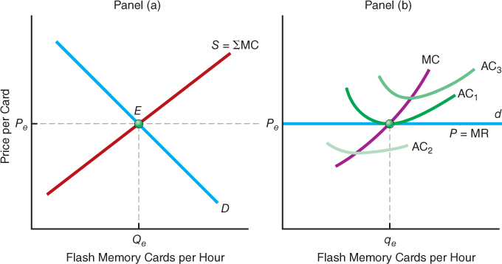

Figure 23-8 Industry Demand and Supply Curves and the Individual Firm Demand Curve
The industry demand curve is represented by D in panel (a). The short-run industry supply curve is S and is equal to ΣMC. The intersection of the demand and supply curves at E determines the equilibrium or market clearing price at P_{e}. The demand curve faced by the individual firm in panel (b) is perfectly elastic at the market clearing price determined in panel (a). If the producer has a marginal cost curve MC, its profit-maximizing output level is at q_{e} . Consider average cost curves AC₃, AC₁, and AC₂ associated with successively higher levels of fixed costs. For AC₁, economic profits are zero. For AC₂, profits are positive. For AC₃, profits are negative.

Self Check
Visit MyEconLab to practice these and other problems and to get instant feedback in your Study Plan.
- The perfectly competitive market price is determined by the of the market demand curve and the curve.
- The position of the individual perfect competitor’s horizontal curve is determined by the market price, and this curve also is the firm’s perfectly curve.

The Long-Run Industry Situation: Exit and Entry
- 23.5 Describe what factors induce firms to enter or exit a perfectly competitive industry and distinguish among constant-, increasing-, and decreasing-cost industries based on the shape of the long-run industry supply curve
In the long run in a competitive situation, firms will be making zero economic profits. (Actually, this is true only for identical firms. Throughout the remainder of the discussion, we assume firms have the same cost structures.) We surmise, therefore, that in the long run a perfectly competitive firm’s marginal revenue curve—which is horizontal at the market clearing price—will just touch its average total cost curve. How does this occur? It comes about through an adjustment process that depends on economic profits and losses.

Exit and Entry of Firms
Look back at both Figure 23-3 on page 535 and Figure 23-4 on page 536. The existence of either profits or losses is a signal to owners of capital both inside and outside the industry. If an industry is characterized by firms showing economic profits as represented in Figure 23-3, these economic profits signal owners of capital elsewhere in the economy that they, too, should enter this industry. In contrast, if some firms in an industry are suffering economic losses as represented in Figure 23-4, these economic losses signal resource owners outside the industry to stay out. In addition, these economic losses signal resource owners within the industry not to reinvest and if possible to leave the industry. It is in this sense that we say that profits direct resources to their highest-valued use. In the long run, capital will flow into industries in which profitability is highest and will flow out of industries in which profitability is lowest.

Allocation of Capital and Market Signals
The price system therefore allocates capital according to the relative expected rates of return on alternative investments. Hence, entry restrictions (such as limits on the numbers of taxicabs and banks permitted to enter the taxi service and banking industries) will hinder economic efficiency by not allowing resources to flow to their highest-valued use. Similarly, exit restrictions (such as laws that require firms to give advance notice of closings) will act to trap resources (temporarily) in sectors in which their value is below that in alternative uses. Such laws will also inhibit the ability of firms to respond to changes in both the domestic and international marketplaces.
Not every industry presents an immediate source of opportunity for every firm. In a brief period of time, it may be impossible for a firm that produces tractors to switch to the production of digital devices, even if there are very large profits to be made. Over the long run, however, we would expect to see owners of some other resources switch to producing digital devices. In a market economy, investors supply firms in the more profitable industry with more investment funds, which they take from firms in less profitable industries. (Also, positive economic profits induce existing firms to use internal investment funds for expansion.) Consequently, resources useful in the production of more profitable goods, such as labor, will be bid away from lower-valued opportunities. Investors and other suppliers of resources respond to market signals about their highest-valued opportunities.
Signals
Compact ways of conveying to economic decision makers information needed to make decisions. An effective signal not only conveys information but also provides the incentive to react appropriately. Economic profits and economic losses are such signals.

What If… the government implemented a policy of taxing away all economic profits while providing subsidies to cover any economic losses?
In effect, this policy would be aimed at keeping firms at their break-even points. The policy indirectly, though, would amount to a restriction on exit from and entry into industries. After all, then in industries in which firms otherwise would experience economic losses, there would be no incentive for any loss-generating incumbents to exit. In contrast, in industries in which firms otherwise would earn positive economic profits, there would be no incentive for additional entry, given that any economic profits entrants might earn would be confiscated. Hence, the policy would prevent capital resources from flowing from loss-generating industries in which those resources fail to reach their highest feasible worth to profit-generating industries in which that worth is attainable. Consequently, the policy would lead to the inefficient allocation of resources.

Tendency Toward Equilibrium
Market adjustment to changes in demand will occur regardless of the wishes of the managers of firms in less profitable markets. They can either attempt to adjust their product line to respond to the new demands, be replaced by managers who are more responsive to new conditions, or see their firms go bankrupt as they find themselves unable to replace worn-out plant and equipment.
In addition, when we say that in a competitive long-run equilibrium situation firms will be making zero economic profits, we must realize that at a particular point in time it would be pure coincidence for a firm to be making exactlyzero economic profits. Real-world information is not as precise as the curves we use to simplify our analysis. Things change all the time in a dynamic world, and firms, even in a very competitive situation, may for many reasons not be making exactly zero economic profits. We say that there is a tendency toward that equilibrium position, but firms are adjusting constantly to changes in their cost curves and in the market demand curves.
How did India’s markets for products derived from an Australian bird find their way to a long-run equilibrium during the past decade?

International Example The Rise and Fall of the Emu Farming Industry in India
The emu is a large, flightless bird native to Australia. A few years after the beginning of this century, however, a number of farmers in India began raising the birds for their eggs, meat, and oil from fatty tissue. Soon, other farmers began raising emus, and by 2008 there were 700,000 emus in India. Many additional farmers entered the emu market during the next four years, and in 2011 an estimated 2 million emus were being raised on emu farms.
By that point, the substantial increase in market supply following these years of market entry had generated substantial decreases in the market clearing prices of emu-derived eggs, meat, and oil. Soon, most Indian emu farmers were earning economic losses. By 2015, many farmers had exited this industry. Today, fewer than 350,000 emus are being raised in India.

For Critical Thinking
- During which years do you suppose that Indian farmers were earning economic profits from raising emus? Explain your reasoning.
Sources are listed at the end of this chapter.
MyEconLab Concept Check

Long-Run Industry Supply Curves
In panel (a) of Figure 23-8 on page 541, we drew the summation of all of the portions of the individual firms’ marginal cost curves at and above each firm’s respective minimum average variable costs as the upward-sloping supply curve of the entire industry. We should be aware, however, that a relatively inelastic supply curve may be appropriate only in the short run. After all, one of the prerequisites of a competitive industry is freedom of entry.
Remember that our definition of the long run is a period of time in which all adjustments can be made. The long-run industry supply curve is a supply curve showing the relationship between quantities supplied by the entire industry at different prices after firms have been allowed to either enter or leave the industry, depending on whether there have been positive or negative economic profits. Also, the long-run industry supply curve is drawn under the assumption that firms are identical and that entry and exit have been completed. This means that along the long-run industry supply curve, firms in the industry earn zero economic profits.
Long-run industry supply curve
A market supply curve showing the relationship between prices and quantities after firms have been allowed the time to enter into or exit from an industry, depending on whether there have been positive or negative economic profits.
The long-run industry supply curve can take one of three shapes, depending on whether input prices stay constant, increase, or decrease as the number of firms in the industry changes. In Chapter 22, we assumed that input prices remained constant to the firm regardless of the firm’s rate of output. When we look at the entire industry, however, when all firms are expanding and new firms are entering, they may simultaneously bid up input prices.

Constant-Cost Industries
In principle, there are industries that use such a small percentage of the total supply of inputs required for industrywide production that firms can enter the industry without bidding up input prices. In such a situation, we are dealing with a constant-cost industry. Its long-run industry supply curve is therefore horizontal and is represented by S_{L} in panel (a) of Figure 23-9 below.
Constant-cost industry
An industry whose total output can be increased without an increase in long-run per-unit costs. Its long-run supply curve is horizontal.
We can work through the case in which constant costs prevail. We start out in panel (a) with demand curve D₁ and supply curve S₁. The equilibrium price is P₁. Market demand shifts rightward to D₂. In the short run, the equilibrium price rises to P₂. This generates positive economic profits for existing firms in the industry. Such economic profits induce capital to flow into the industry. The existing firms expand or new firms enter (or both). The short-run supply curve shifts outward to S₂. The new intersection with the new demand curve is at E₃. The new equilibrium price is again P₁. The long-run supply curve, labeled S_{L}, is obtained by connecting the intersections of the corresponding pairs of demand and short-run supply curves, E₁ and E₃.
In a constant-cost industry, long-run supply is perfectly elastic. Any shift in demand is eventually met by just enough entry or exit of suppliers that the long-run price is constant at P₁. Retail trade is often given as an example of such an industry because output can be expanded or contracted without affecting input prices. Banking is another example.
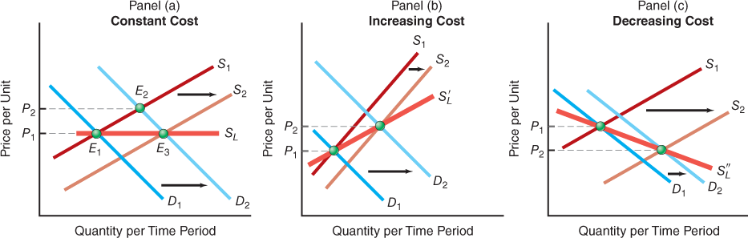

Figure 23-9 Constant-Cost, Increasing-Cost, and Decreasing-Cost Industries
In panel (a), we show a situation in which the demand curve shifts from D₁ to D₂. Price increases from P₁ to P₂. In time, the short-run supply curve shifts outward because entry occurs in response to positive profits, and the equilibrium changes from E₂ to E₃. The market clearing price is again P₁. If we connect points such as E₁ and E₃, we come up with the long-run supply curve S_{L}. This is a constant-cost industry. In panel (b), costs are increasing for the industry, and therefore the long-run supply curve, S′_{L}, slopes upward and long-run prices rise from P₁ to P₂. In panel (c), costs are decreasing for the industry as it expands, and therefore the long-run supply curve, S′′_{L}, slopes downward such that long-run prices decline from P₁ to P₂.

Increasing-Cost Industries
In an increasing-cost industry , expansion by existing firms and the addition of new firms cause the price of inputs specialized to that industry to be bid up. As costs of production rise, the ATC curve and the firms’ MC curves shift upward, causing short-run supply curves (each firm’s marginal cost curve) to shift vertically upward. Hence, industry supply shifts out by less than in a constant-cost industry. The result is a long-run industry supply curve that slopes upward, as represented by S′_{L} in panel (b) of Figure 23-9. Examples are residential construction and coal mining—both use specialized inputs that cannot be obtained in ever-increasing quantities without causing their prices to rise.
Increasing-cost industry
An industry in which an increase in industry output is accompanied by an increase in long-run per-unit costs, such that the long-run industry supply curve slopes upward.

Decreasing-Cost Industries
An expansion in the number of firms in an industry can lead to a reduction in input costs and a downward shift in the ATC and MC curves. When this occurs, the long-run industry supply curve will slope downward. An example, S′_{L}, is given in panel (c) of Figure 23-9. This is a decreasing-cost industry.
Decreasing-cost industry
An industry in which an increase in output leads to a reduction in long-run per-unit costs, such that the long-run industry supply curve slopes downward.
Is the bottled-water industry a constant-cost, increasing-cost, or decreasing-cost industry?

Example Long-Run Supply in the Bottled-Water Industry
Between 1975 and 2005, U.S. sales of water offered in 20-ounce plastic bottles doubled every five years, though sales growth by 2015 has slowed noticeably. As the market demand curve for bottled water has shifted rightward during the past forty years, so has the number of firms that specialize in purifying water and placing it in bottles. This persistent entry of new firms has caused the market supply curve for bottled water to shift rightward as well.
Although there have been short-term fluctuations in the inflation-adjusted market clearing price of water, this price has remained remarkably stable as demand has increased and entry of firms has boosted supply. Four decades ago, the average inflation-adjusted price (measured in today’s dollars) of a 20-ounce bottle of water was approximately 90 cents, and this price has remained at approximately 90 cents up to the present. The fact that the market clearing price of bottled water did not change over this period of growing market demand and entry by firms indicates that the bottled-water industry is a constant-cost industry.

For Critical Thinking
- What is the shape of the long-run industry supply curve for the bottled-water industry? Explain briefly.
Sources are listed at the end of this chapter.
MyEconLab Concept Check

Long-Run Equilibrium
In the long run, the firm can change the scale of its plant, adjusting its plant size in such a way that it has no further incentive to change. It will do so until profits are maximized.

The Firm’s Long-Run Situation
Figure 23-10 on the next page shows the long-run equilibrium of the perfectly competitive firm. Given a price of Pand a marginal cost curve, MC, the firm produces at output q_{e} . Because economic profits must be zero in the long run, the firm’s short-run average costs (SAC) must equal P at q_{e}, which occurs at minimum SAC. In addition, because we are in long-run equilibrium, any economies of scale must be exhausted, so we are on the minimum point of the long-run average cost curve (LAC). In other words, the long-run equilibrium position is where “everything is equal,” which is at point E in Figure 23-10. There, price equals marginal revenue equals marginal cost equals average cost(minimum, short-run, and long-run).

Perfect Competition and Minimum Average Total Cost
Look again at Figure 23-10 on the next page. In long-run equilibrium, the perfectly competitive firm finds itself producing at output rate q_{e} . At that rate of output, the price is just equal to the minimum long-run average cost as well as the minimum short-run average cost. In this sense, perfect competition results in the production of goods and services using the least costly combination of resources. This is an important attribute of a perfectly competitive long-run equilibrium, particularly when we wish to compare the market structure of perfect competition with other market structures that are less than perfectly competitive. We will examine these other market structures in later chapters.
MyEconLab Animation
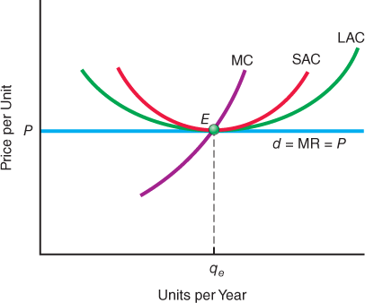

Figure 23-10 Long-Run Firm Competitive Equilibrium
In the long run, the firm operates where price, marginal revenue, marginal cost, short-run minimum average cost, and long-run minimum average cost are all equal. This condition is satisfied at point E.
MyEconLab Concept Check

Competitive Pricing: Marginal Cost Pricing
In a perfectly competitive industry, each firm produces where its marginal cost curve intersects its marginal revenue curve from below. Thus, perfectly competitive firms always sell their goods at a price that just equals marginal cost. This is said to be the optimal price of this good because the price that consumers pay reflects the opportunity cost to society of producing the good. Recall that marginal cost is the amount that a firm must spend to purchase the additional resources needed to expand output by one unit. Given competitive markets, the amount paid for a resource will be the same in all of its alternative uses. Thus, MC reflects relative resource input use. That is, if the MC of good 1 is twice the MC of good 2, one more unit of good 1 requires twice the resource input of one more unit of good 2.

Marginal Cost Pricing
The competitive firm produces up to the point at which the market price just equals the marginal cost. Herein lies the element of the optimal nature of a competitive solution, which is called marginal cost pricing.
Marginal cost pricing
A system of pricing in which the price charged is equal to the opportunity cost to society of producing one more unit of the good or service in question. The opportunity cost is the marginal cost to society.

Matching the Consumer’s Marginal Benefit
The competitive firm sells its product at a price that just equals the cost to society—the opportunity cost—for that is what the marginal cost curve represents. But note here that it is the self-interest of firm owners that causes price to equal the marginal cost to society.
In other words, the marginal benefit to consumers, given by the price that they are willing to pay for the last unit of the good purchased, just equals the marginal cost to society of producing the last unit. If the marginal benefit exceeds the marginal cost, that is, if P > MC, too little is being produced in that people value additional units more than the cost to society of producing them. If P < MC -->, the opposite is true.

The Efficiency of Marginal Cost Pricing
When an individual pays a price equal to the marginal cost of production, the cost to the user of that product is equal to the sacrifice or cost to society of producing that quantity of that good as opposed to more of some other good. (We are assuming that all marginal social costs are accounted for.) The competitive solution, then, is called efficient, in the economic sense of the word. Economic efficiency means that it is impossible to increase the output of any good without lowering the value of the total output produced in the economy. No juggling of resources, such as labor and capital, will result in an output that is higher in total value than the value of all of the goods and services already being produced. In an efficient equilibrium, it is impossible to make one person better off without making someone else worse off. All resources are used in the most advantageous way possible, and society therefore enjoys an efficient allocation of productive resources. All goods and services are sold at their opportunity cost, and marginal cost pricing prevails throughout.

Market Failure
Although perfect competition does offer many desirable results, situations arise when perfectly competitive markets cannot efficiently allocate resources. Either too many or too few resources are used in the production of a good or service. These situations are instances of market failure. Externalities arising from failures to fully assign property rights and public goods are examples. For reasons discussed in later chapters, perfectly competitive markets cannot efficiently allocate resources in these situations, and alternative allocation mechanisms may be called for. In some cases, alternative market structures or government intervention may improve the economic outcome.
MyEconLab Concept Check
MyEconLab Study Plan
Market failure
A situation in which an unrestrained market operation leads to either too few or too many resources going to a specific economic activity.

Self Check
Visit MyEconLab to practice these and other problems and to get instant feedback in your Study Plan.
- In the long run, perfectly competitive firms make economic profits because of entry and exit whenever there are industrywide economic profits or losses.
- A constant-cost industry has a long-run supply curve. An increasing-cost industry has an -sloping long-run supply curve. A decreasing-cost industry has a -sloping long-run supply curve.
- In the long run, a perfectly competitive firm produces to the point at which price, marginal revenue, marginal cost, short-run minimum average cost, and long-run minimum average cost are all .
- Perfectly competitive pricing is essentially pricing. Therefore, the perfectly competitive solution is called efficient because represents the social opportunity cost of producing one more unit of the good.

You are There Reaching the Short-Run Shutdown Point in the Ethanol Industry
Geoff Cooper, vice president for research and analysis at the Renewable Fuels Association, looks again at data on the prices of corn and ethanol, a fuel blended with gasoline used in most vehicles. A drought has wiped out part of the U.S. corn crop, which consequently will be at least one-third smaller than in the prior year. Thus, the market clearing price of corn has jumped significantly, from just over $4 per bushel to close to $7 per bushel.
In the past, the production of ethanol has required close to 40 percent of the nation’s corn crop. Cooper knows that ethanol producers will not purchase nearly that share of the corn crop this year, though. The average cost of corn required to produce a gallon of ethanol has now risen above the market clearing price of ethanol. In response, ethanol firms in 13 different states have shut down operations at 25 of the nation’s 211 ethanol-producing plants. Cooper releases a statement to the press: “If we get back to a normal climate pattern and a normal corn crop, then I think the industry is in good shape,” the statement reads. “But if this drought persists and it has the same effect on this coming corn crop, then we’ve got a problem.” So far, Cooper knows, ethanol firms are keeping their plants in place and only temporarily laying off some of their employees. If corn prices do remain as high next year, however, continuing losses likely will lead firms to close plants permanently and dismiss many of their workers.

Critical Thinking Questions
- Below what type of short-run average cost has the price of ethanol fallen?
- Does Cooper appear to view the coming year as a short-run or long-run period?
Sources are listed at the end of this chapter.

Issues & Applications
Firm Entry—and Exit—in Competitive U.S. Markets
MyEconLab Video


Concepts Applied
- Firm Entry
- Firm Exit
- Perfect Competition
More than 500,000 new private businesses begin operations each year in the United States. Year after year, these hundreds of thousands of firms enter industries in response to profit opportunities perceived by the entrepreneurs who go about organizing the resources required to bring them into being. Nevertheless, many of these firms also exit their industries in the years that follow.

In Competitive Markets, Survival Is Not Guaranteed
Figure 23-11 displays the average percentage of new business entrants still operating in U.S. markets at each age, measured in years, of their operations. By definition, firms are alive during their initial year, so this percentage is always 100 percent in year 1.
The figure indicates that less than 79 percent of U.S. firms survive their first year of operations. By the sixth year, fewer than half are still in business. Ultimately, less than 23 percent typically survive to reach their twentieth birthday. Thus, more than 77 percent of U.S. firms eventually close down their operations and exit their industries.
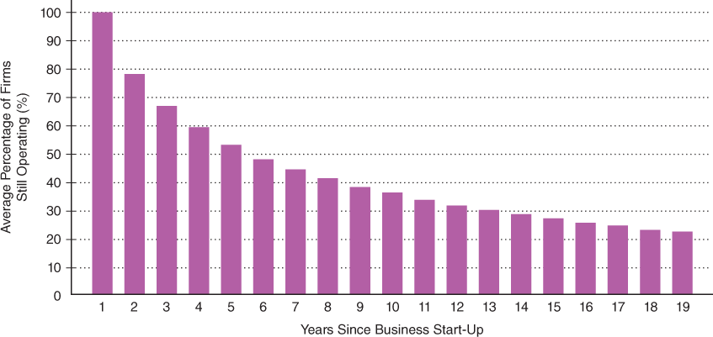

Figure 23-11 The Average Number of Firms Still Operating in Years Following Initial Entry
Only about half of firms ultimately survive the first six years following their initial entry into U.S. markets. Fewer than one in four firms survive to reach a twentieth year of existence.
Source: U.S. Bureau of Labor Statistics.

The Perfectly Competitive Long Run: Break-Even Profits Only
Entrepreneurs open firms with anticipations of earning positive economic profits. Why is it, therefore, that three-fourths of U.S. firms eventually close?
The theory of perfect competition provides the answer to this question. In the long run, firms in competitive industries with easy entry and exit earn zero economic profits. Over short-run horizons, however, the positions of market demand curves and of firms’ marginal cost curves and, hence, market supply curves can vary for a wide variety of reasons. As these curves shift, market clearing prices increase and decrease, and the short-term economic profits of incumbent firms rise above and fall below zero. Naturally, we will observe entry into industries in which incumbents earn economic profits for a time. In contrast, we will see exits of incumbents from industries in which incumbents experience periods of economic losses. These periodic exits accumulate, and progressively fewer firms that entered markets in previous years survive. Eventually, only a fraction of incumbent firms that entered in the past will remain in business.

For Critical Thinking
- How would the survival pattern shown in Figure 23-11 be altered if firms earned no less than zero economic profits every single year?
- In what way would Figure 23-11 change if the U.S. government were to offer special lending programs to firms struggling to remain in business because of temporary economic losses? Explain your reasoning.

Web Resources
- To view survey data on the failure rates for new business entrants for different industries, see the Web Links in MyEconLab.
- For the latest data on U.S. business survival rates, see the Web Links in MyEconLab.

MyEconLab
For more questions on this chapter’s Issues & Applications, go to MyEconLab.
In the Study Plan for this chapter, select Section I: Issues and Applications.
Sources are listed at the end of this chapter.

Fundamental Points
- The four fundamental characteristics of a perfectly competitive market are large numbers of buyers and sellers, a homogeneous product, possession of good information by buyers and sellers, and minimal impediments to entry into or exit from the market.
- A perfectly competitive firm maximizes its economic profits by producing the output rate at which marginal revenue equals marginal cost.
- The short-run supply curve is the firm’s marginal cost curve for the range of outputs above the short-run shutdown point at which price equals average variable cost, and the market supply curve equals the horizontal summation of all firms’ short-run supply curves.
- The price observed in a perfectly competitive industry is the market clearing price at which the quantity demanded by all buyers equals the quantity supplied by all firms at the point of intersection of the market demand curve and the market supply curve.
- In the long-run equilibrium for a perfectly competitive industry, the market clearing price equals the minimum level of average total cost, so firms earn zero economic profits.

